**YOUTUBE DATA ANALYSIS**

PROJECT REPORT

Big Data Analytics (ITE2013)

By

|  |  |
| --- | --- |
| SHREYA AKHOURI | 15BIT0122 |
| SOURABH AGRAWAL | 15BIT0298 |

**SLOT**: G1+TG1

**NAME OF THE FACULTY: Dr. K Ganesan**

(**SCHOOL OF INFORMATION TECHNOLOGY)**



**DECLARATION**

We, the students of B. Tech., III year of VIT University, Vellore with registration numbers and names

**Shreya Akhouri** - 15BIT0122

**Sourabh Agrawal -** 15BIT0298

Hereby, declare that the project report entitled **“YOUTUBE DATA ANALYSIS”** submitted by us to VIT University, Vellore, in partial fulfilment of the requirement for the course **“Big Data Analytics”** with course code **ITE2013**, is a bonafide work carried out by us under the supervision of **Dr. K Ganesan**, School of Information Technology, VIT University, Vellore – 632014. We further declare that the work reported in this project has not been submitted and will not be submitted, either in part or in full, for the award of any other degree or diploma in or any other Institute or University.

**Place: Vellore**

**Date**

**ACKNOWLEDGEMENT**

At the outset, we thank the Almighty God for his blessings for granting us the knowledge and right aptitude to successfully complete our project work.

We would like to express our special gratitude and thanks to our guide Dr. K Ganesan, School of Information Technology, whose esteemed guidance and immense support encouraged us to complete the project successfully.

We also thank all the faculty members of other departments of the School of Information Technology and the non-teaching staff for giving us the courage and strength that we needed to achieve my goals.

Our special thanks to our friends for their timely help and suggestions rendered for the successful completion of this project.

This acknowledgement would be incomplete without expressing our whole hearted thanks to our parents for their continuous support and guidance in all walks of our life.

**TABLE OF CONTENT**

|  |  |  |
| --- | --- | --- |
| **S. No.** | **TITLE** | **PAGE NO.** |
| 1 | About | 5 |
| 2 | Tools Used | 6 |
| 3 | Implementation | 7 |
| 4 | Data Set Description | 7 |
| 5 | Process and Result | 8-32 |
| 6 | Application | 33 |
| 7 | References | 33 |

**ABOUT**

Data analysis, also known as analysis of data or data analytics, is a process of inspecting, cleansing, transforming, and modelling data with the goal of discovering useful information, suggesting conclusions, and supporting decision-making. Data analysis has multiple facets and approaches, encompassing diverse techniques under a variety of names, in different business, science, and social science domains.

In this project we are going to find out the below top searches in the following categories like views, uploader, liked, category etc for YouTube data set.

After classifying we can show the top main ten websites used by people via bar chart in which we will be using java.

**TOOLS USED**

• **Hadoop** - Hadoop is an open source, Java-based programming framework that supports the processing and storage of extremely large data sets in a distributed computing environment. It is part of the Apache project sponsored by the Apache Software Foundation

• **LINUX**- LINUX is a name which broadly denotes a family of free and open-source software operating system distributions built around the Linux kernel.

• **Java**- Java is a general-purpose computer programming language that is concurrent, class-based, object-oriented, and specifically designed to have as few implementation dependencies as possible.

• **Android Studio**- Android Studio is the official integrated development environment for Google’s Android operating system.

**IMPLEMENTATION**

This project, we implemented via Hadoop in which we took YouTube data and formed data set as shown in the next content. After getting the data of top 5 data sets, we categorized via map reduce in Hadoop and then plotted bar chart via android studio where we used java language.

**DATA SET DESCRIPTION**

Dataset has following columns:

* Video ID of 11 characters
* Uploader of the video
* Interval between the day of establishment of YouTube and the date of uploading of the video.
* Category of the video
* Length of the video
* Number of views for the video.
* Rating of the video
* Number of Likes given for the video
* Comments in the video
* Related video ids with the uploaded video

**Process of Hadoop:**

* At first, we created 2 accounts in our ubuntu desktop. In “hduser” we installed Hadoop single node cluster.
* We moved out database, which is in .txt format, to hduser account and then we put in hdfs.
  + hdfs dfs -mkdir Top5
  + hdfs dfs -put youtubedata.txt Top5

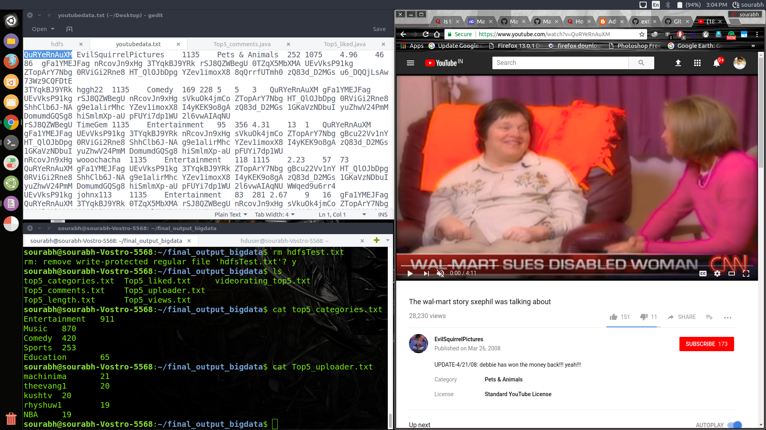

* For getting the output, we first compiled the java file using Hadoop library and then we made an empty directory and stored all the resultant class files in that directory. Then we created the jar file of that new directory.
  + mkdir Top5_categories
  + javac -classpath hadoop-core-1.2.1.jar -d Top5_categories Top5_categories.java
  + cd Top5_categories
  + jar -cf Top5_categories.jar *.class

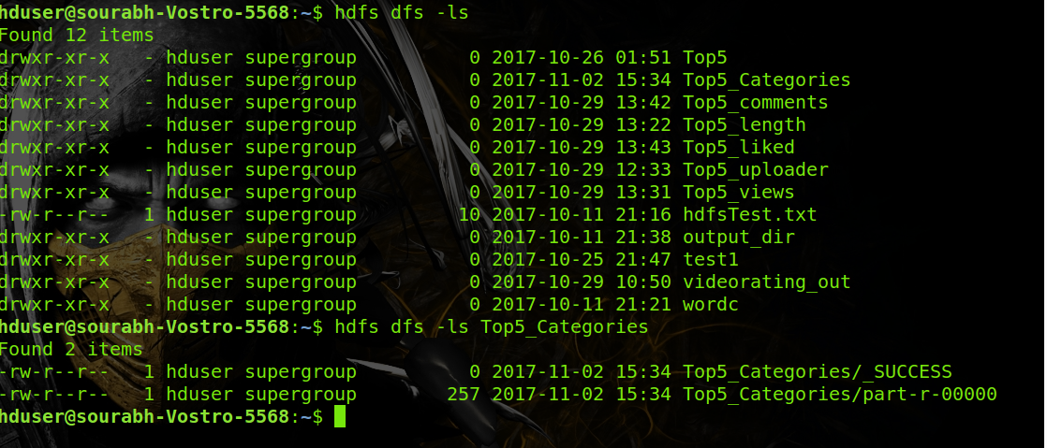

* After making jar file we moved it to hduser account.
  + sudo mv Top5_categories /home/hduser
* Then we compiled the jar file by giving input_dir and out_put dir
  + Hadoop jar Top5_categories.jar Top5_categories Top5 Top5_categories

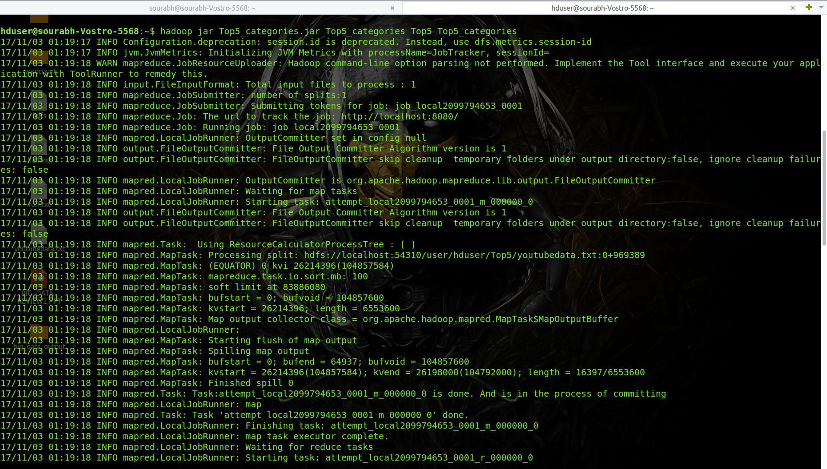

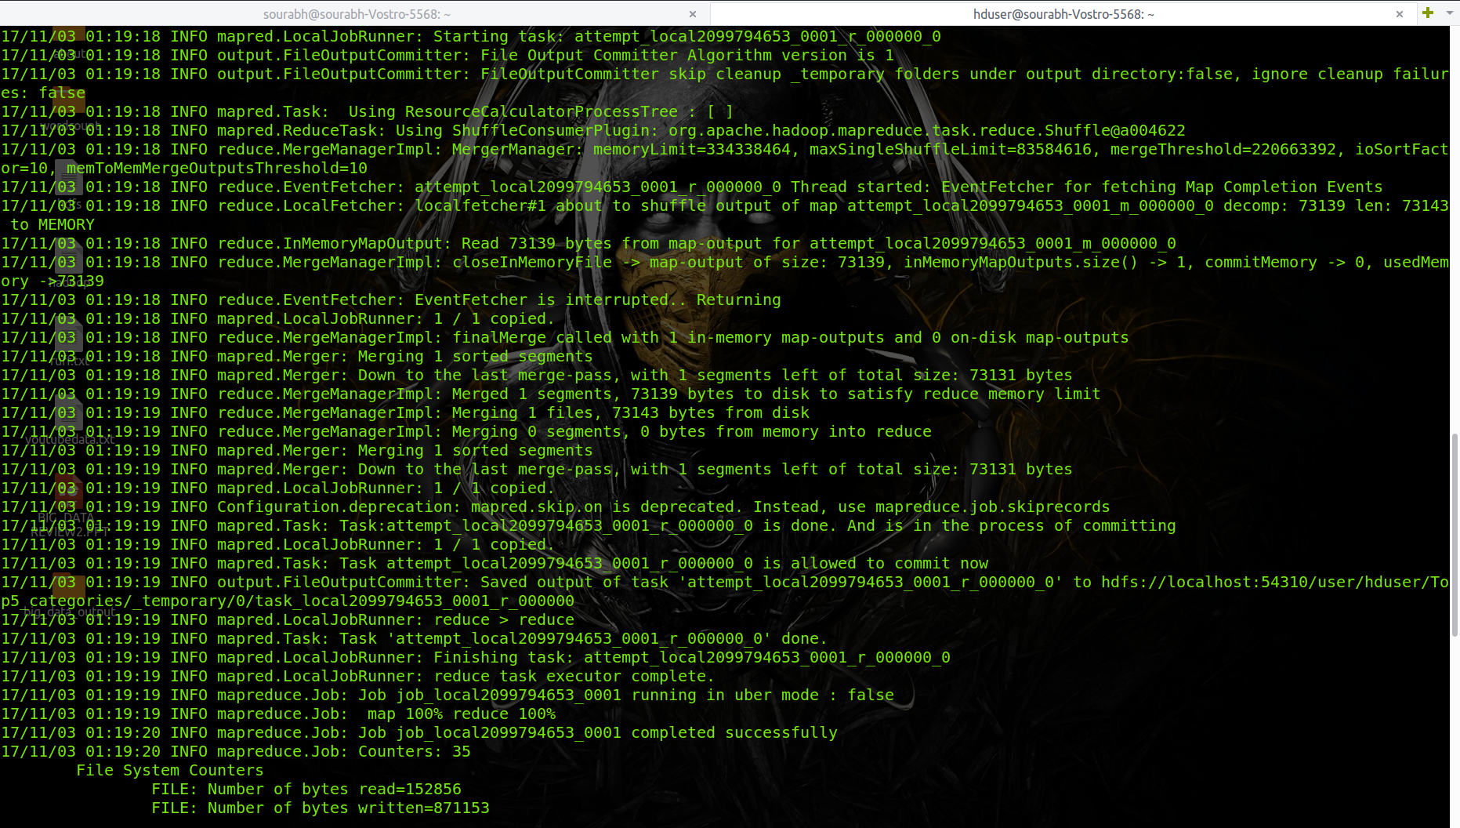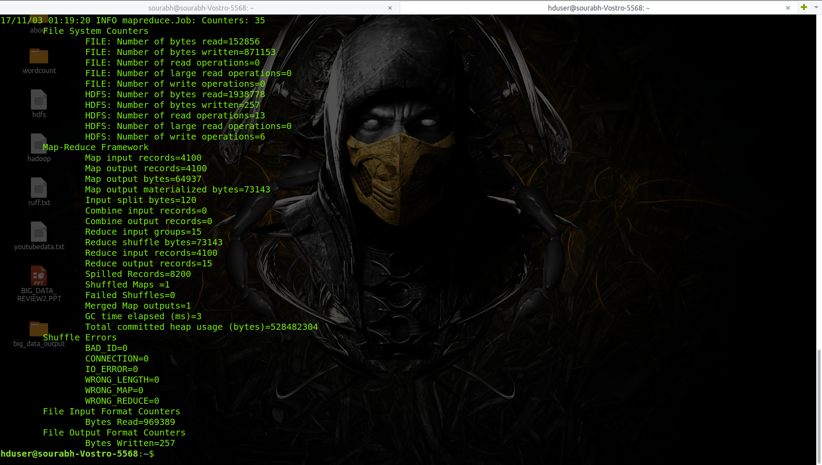

* After successful compilation result can be seen by the following command
  + hdfs dfs -cat Top5_categories/part-r-00000
* Then we are sorting the result for getting Top5 results.
  + hdfs dfs -cat Top5_categories/part-r-00000 |sort -n -k2 -r | head -n5

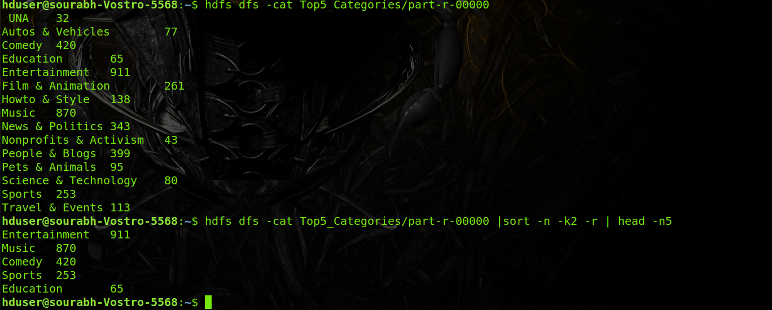

* Then we will save the Top5 result in a txt file.
  + hdfs dfs -cat Top5_categories/part-r-00000 |sort -n -k2 -r | head -n5 > Top5_categories.txt
* The output txt file is used for making the mobile app
* The output of mobile app is:

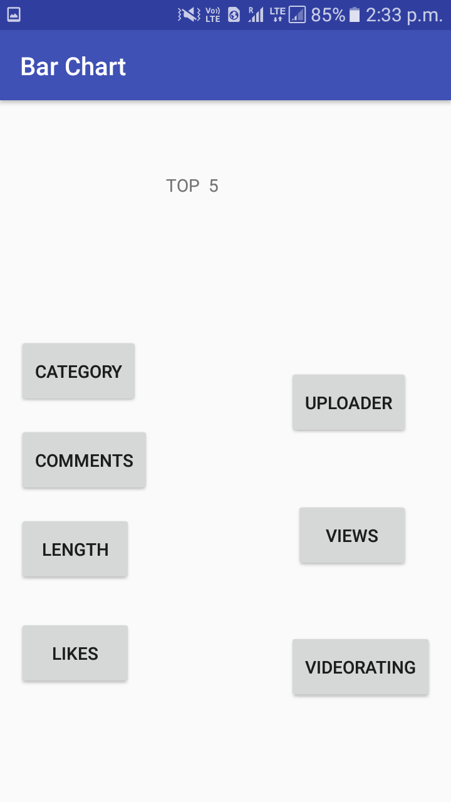

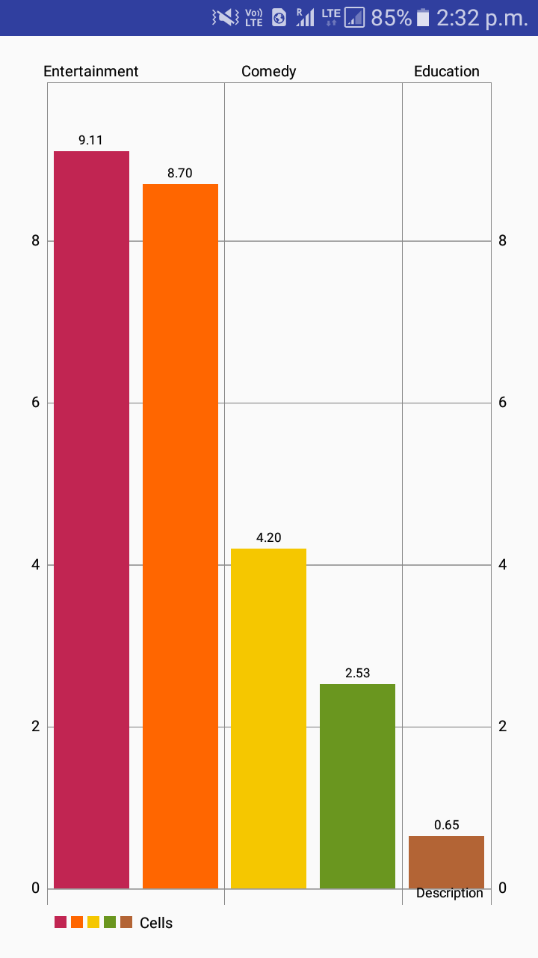

* Then we repeated the process 6 times to get different-different results type wise. They are following:

1. **Top5_uploader:**

In this we are finding who are the Top5_uploaders from the complete dataset

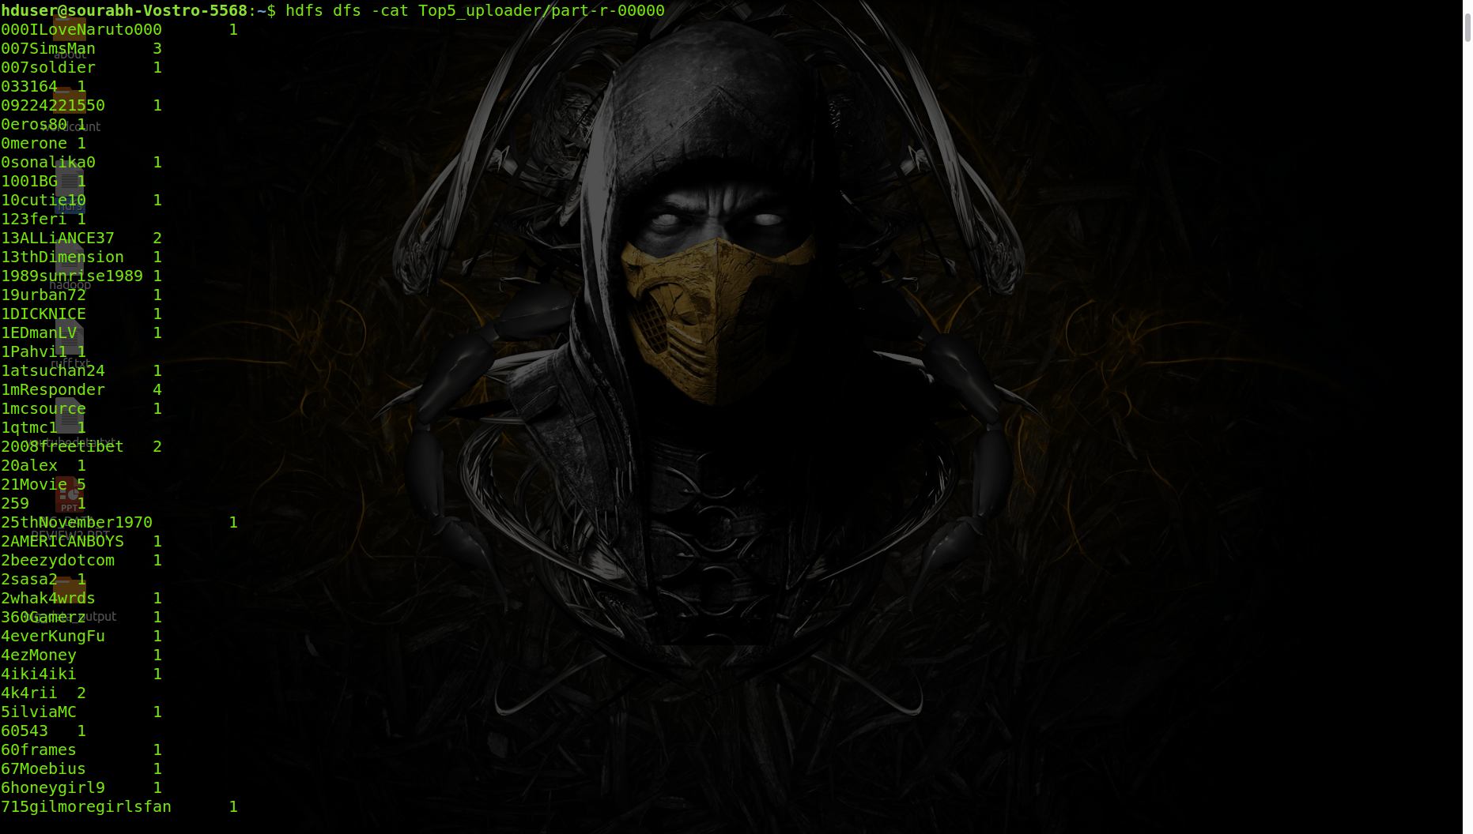

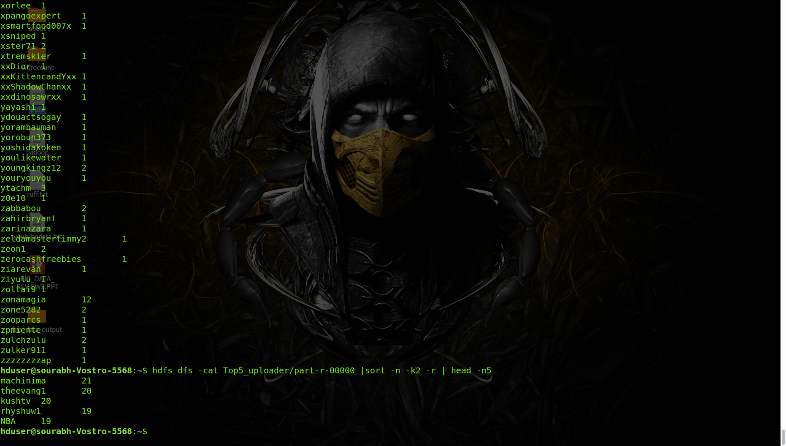

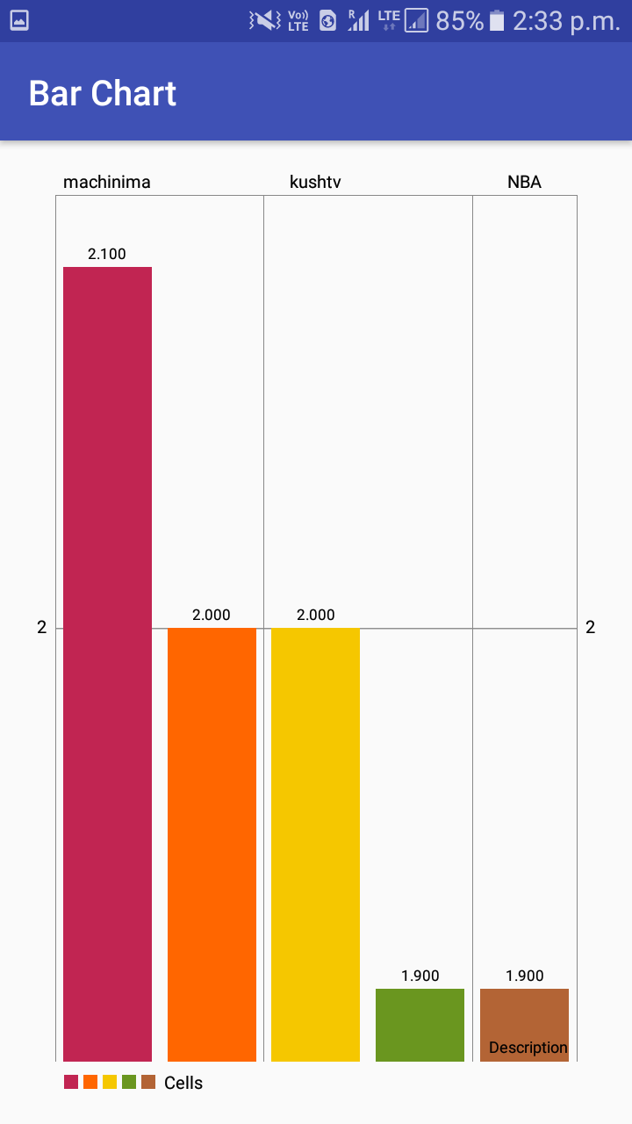

1. **Top5_comments**

In this we are finding who are the Top5_commented videos from the complete dataset

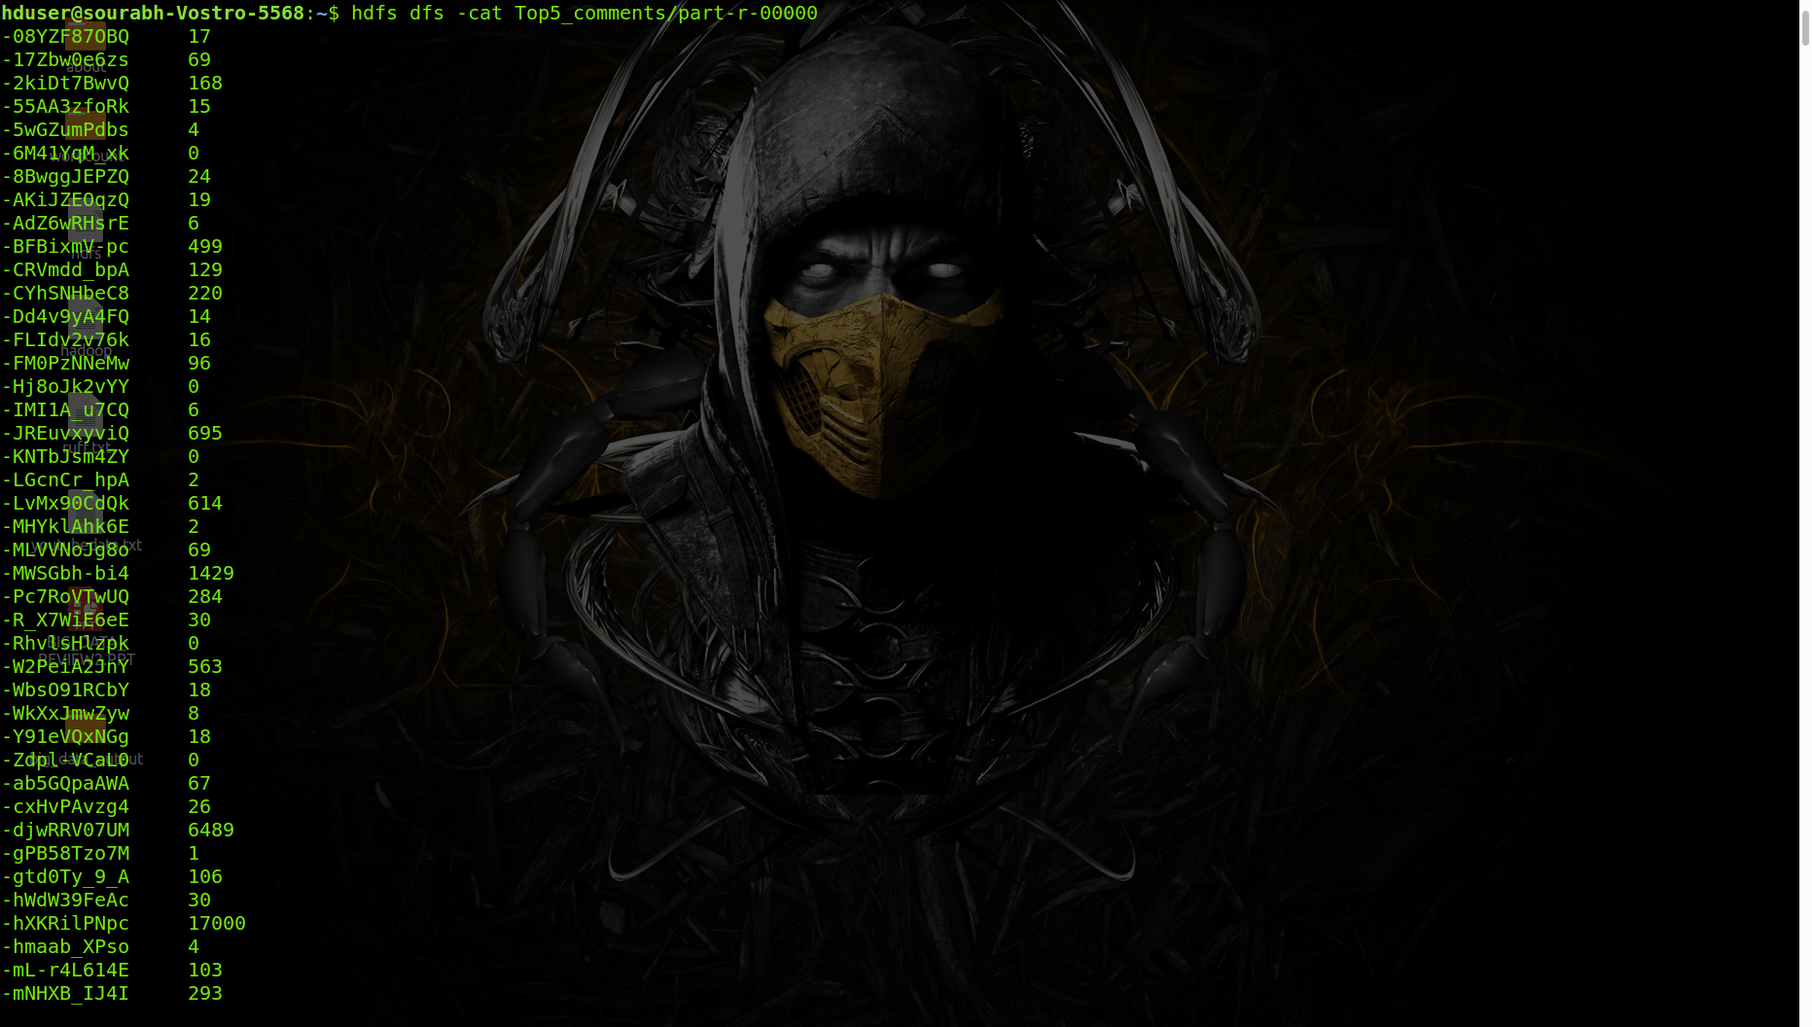

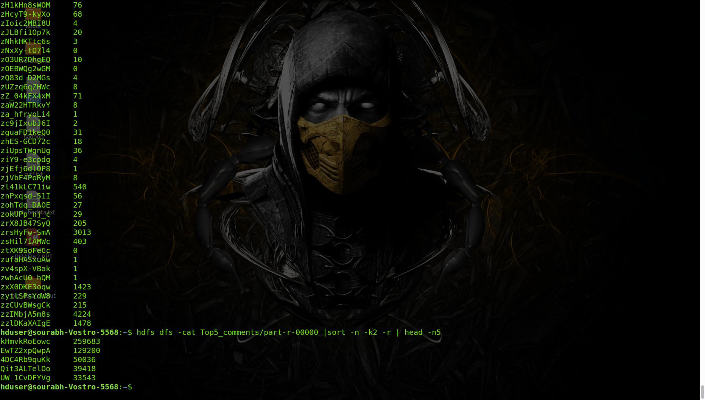

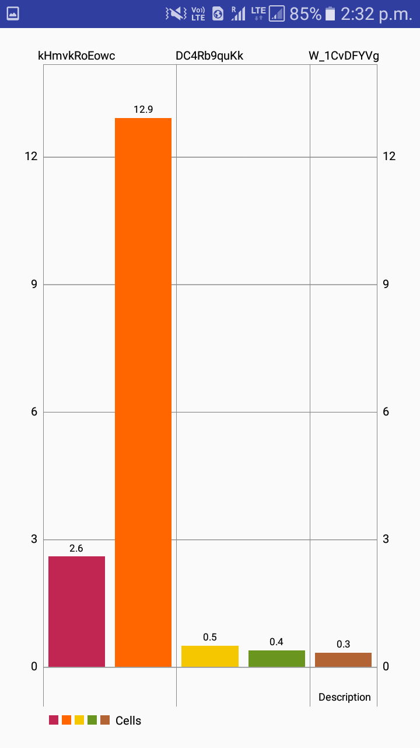

1. **Top5_length**

In this we are finding who are the Top5_longest videos length vice from the complete dataset.

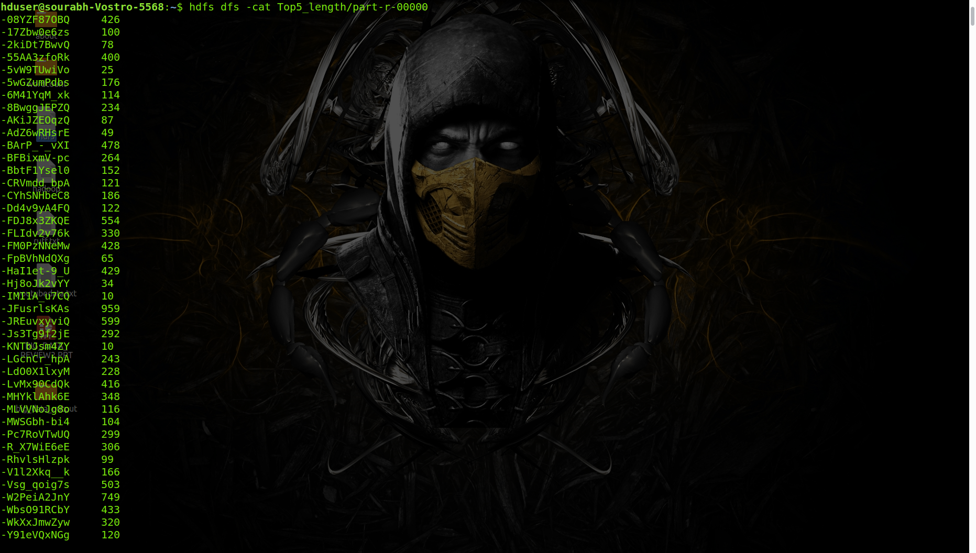

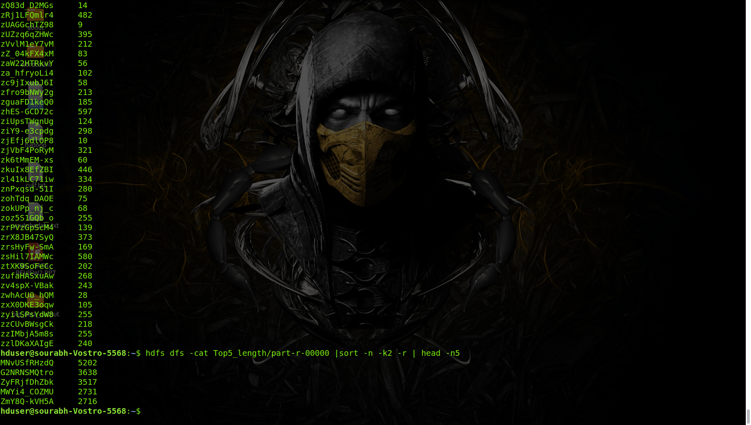

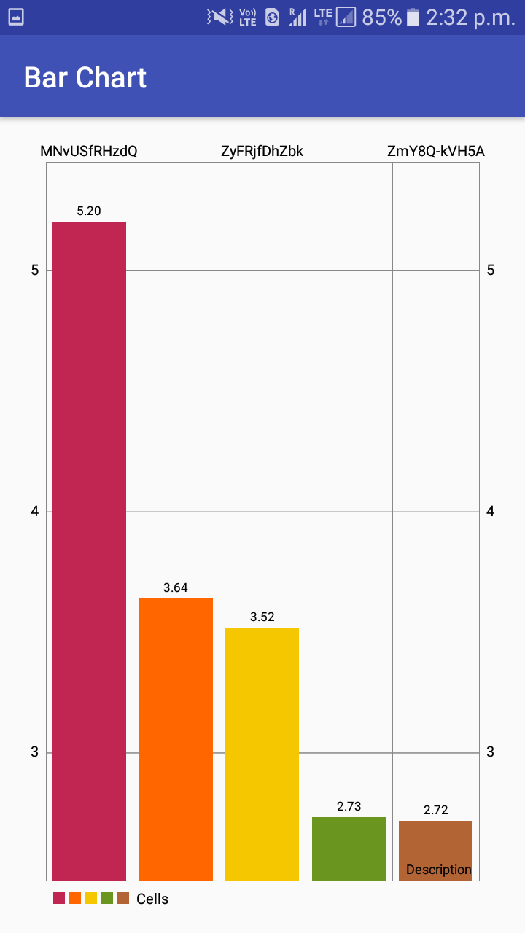

1. **Top5_liked**

In this we are finding who are the Top5_liked videos from the complete dataset

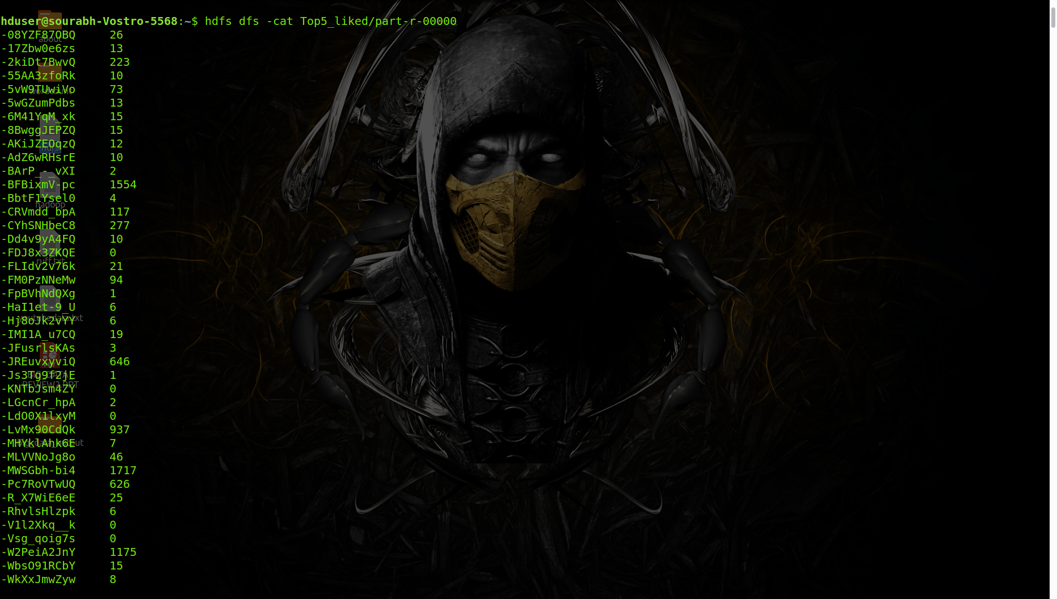

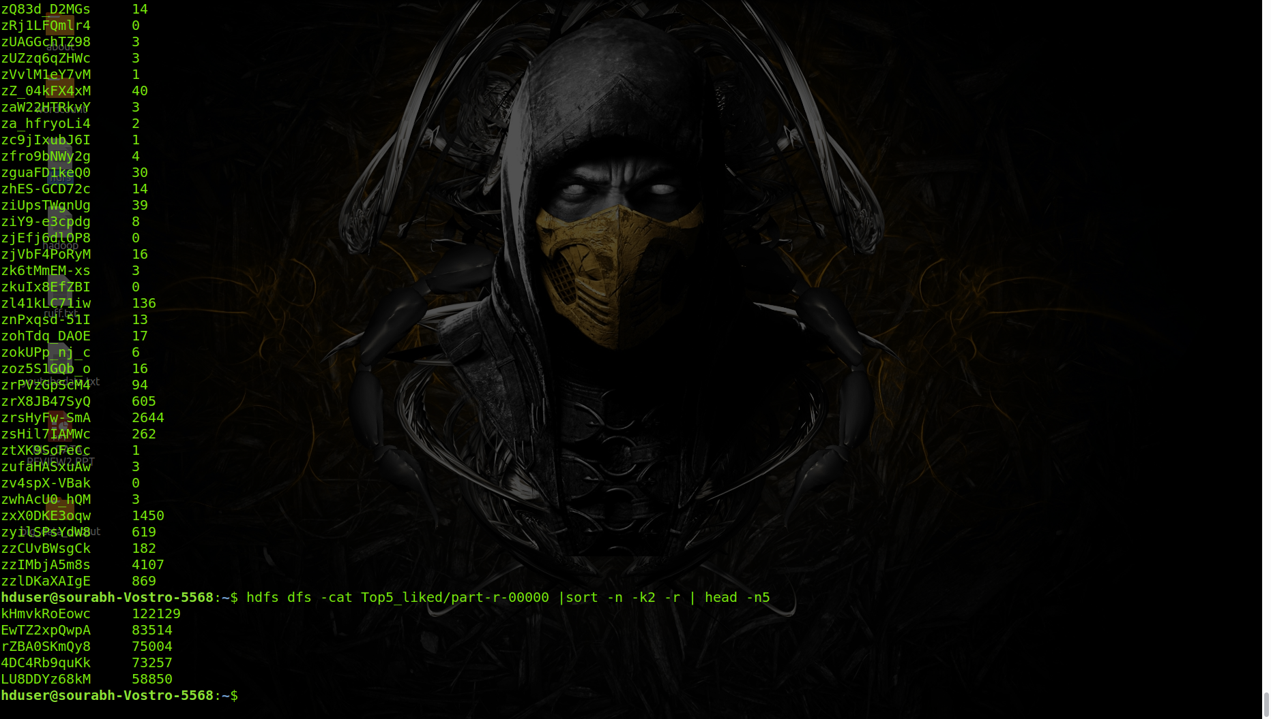

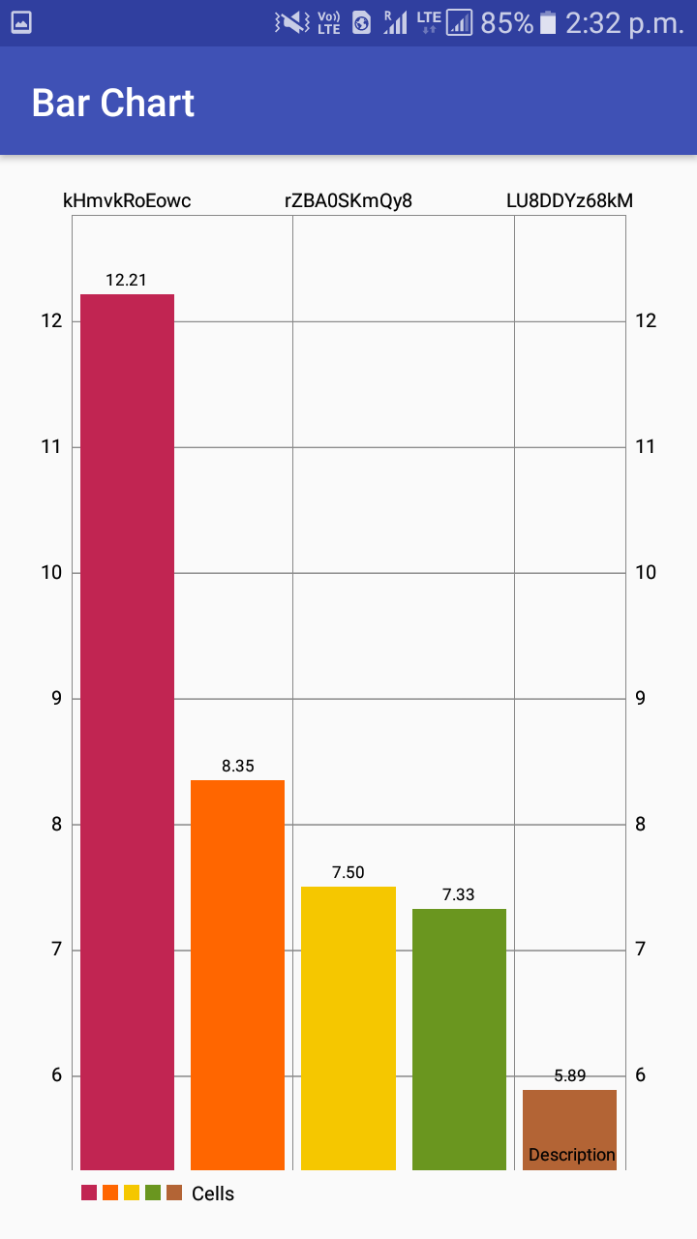

1. **Top5_views**

In this we are finding which Top5_videoes has highest number of views from the complete dataset

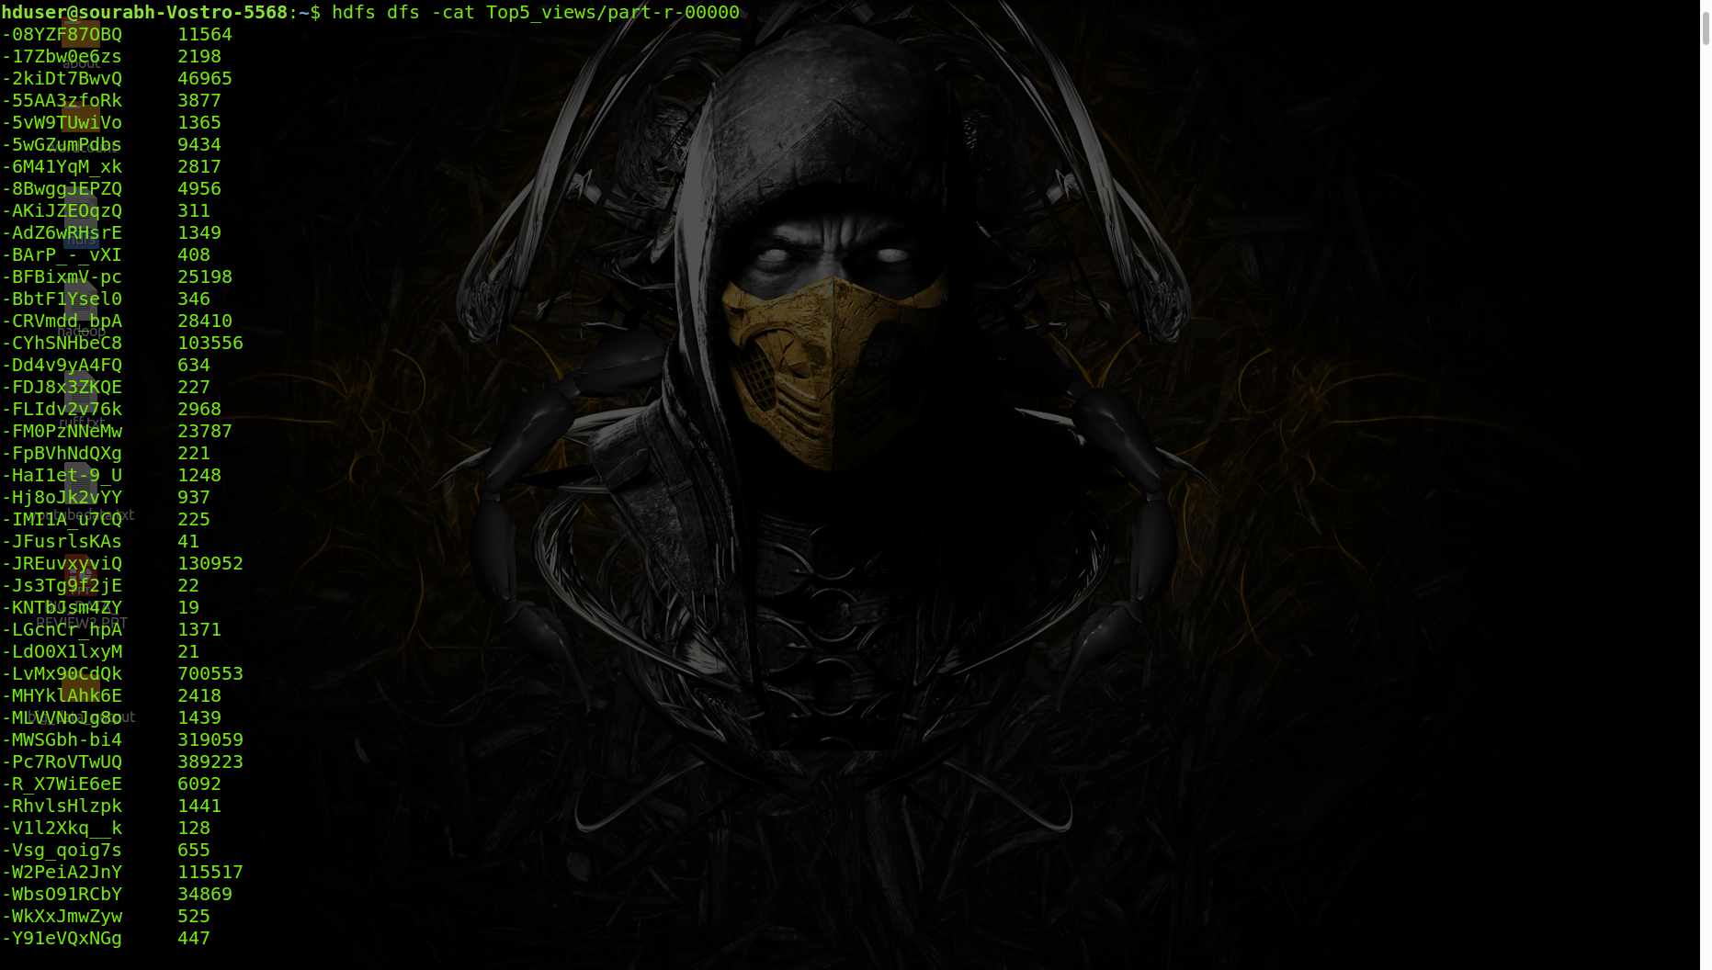

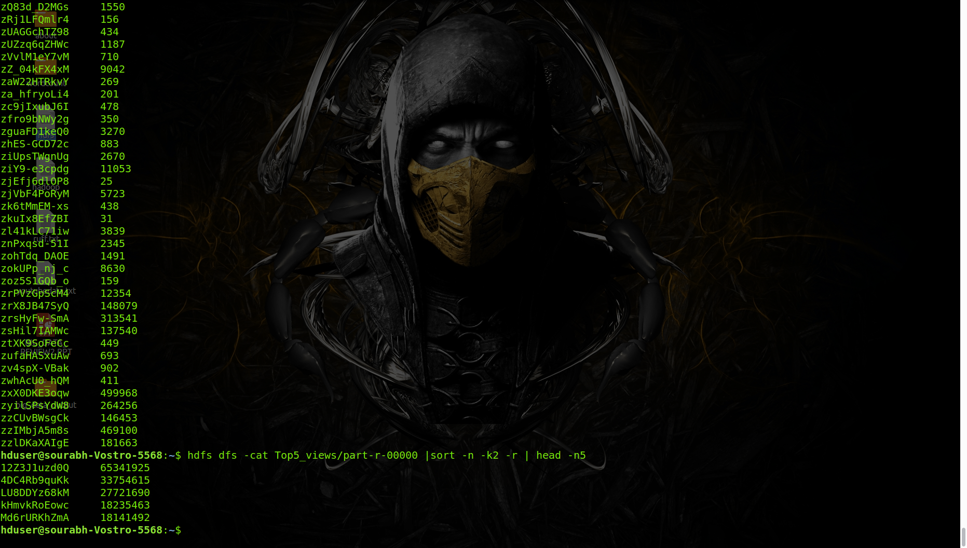

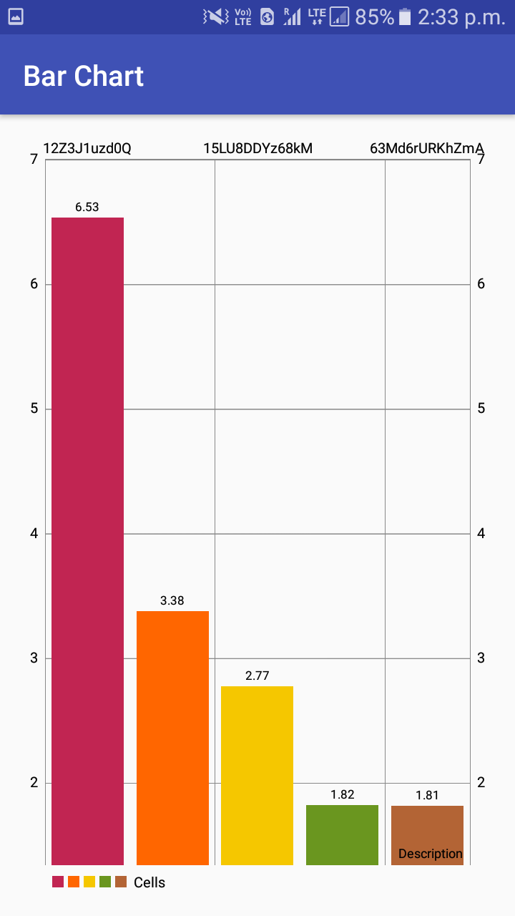

1. **video rating**

In this we are finding who are the Top5_rated videos from the complete dataset

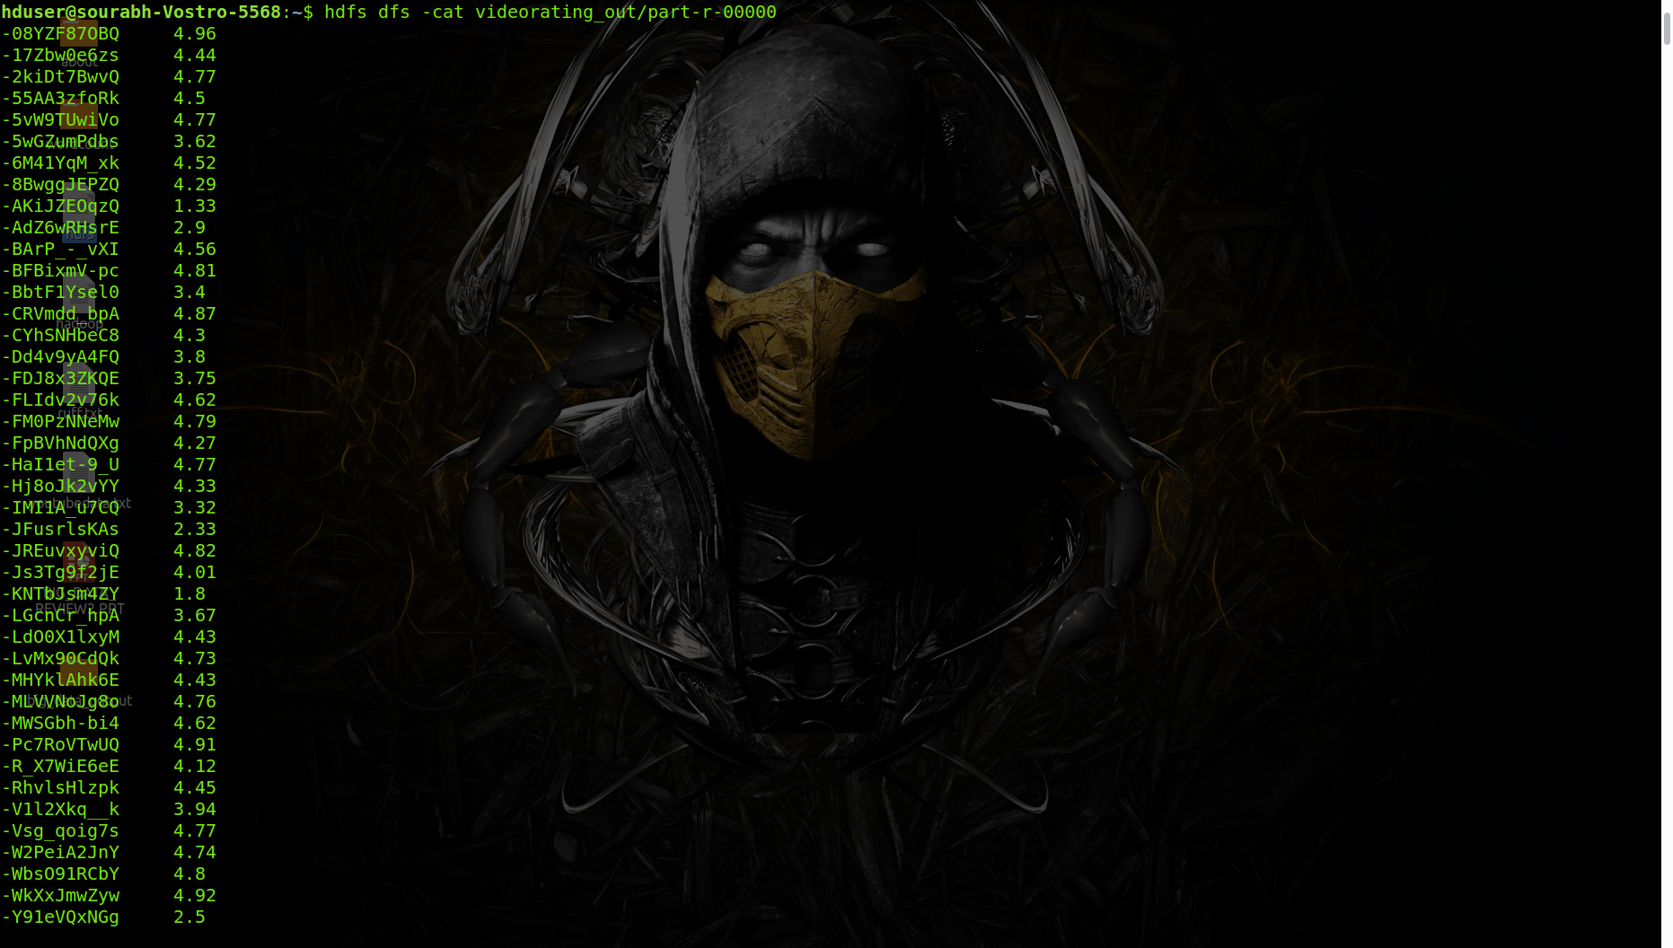

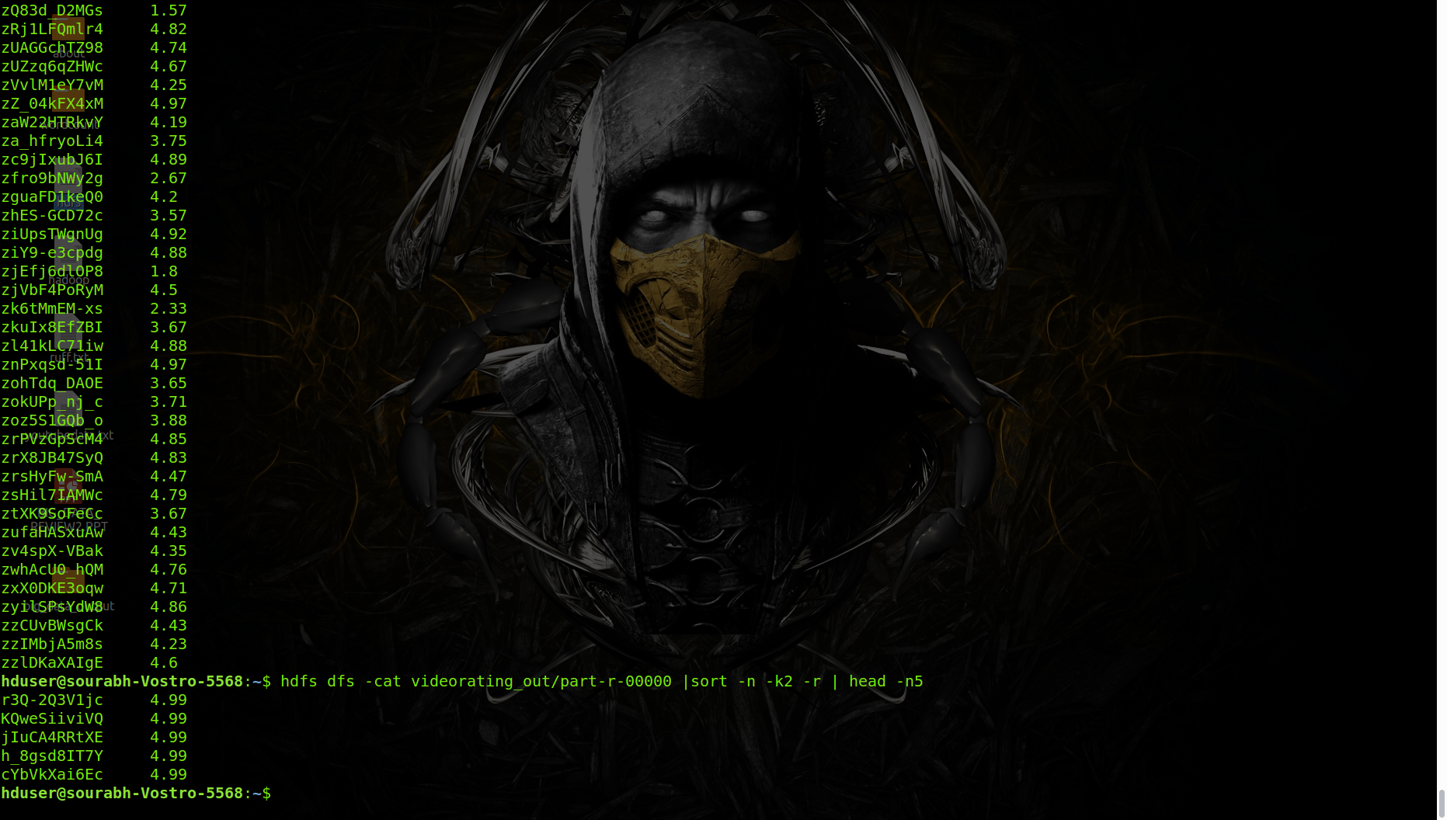

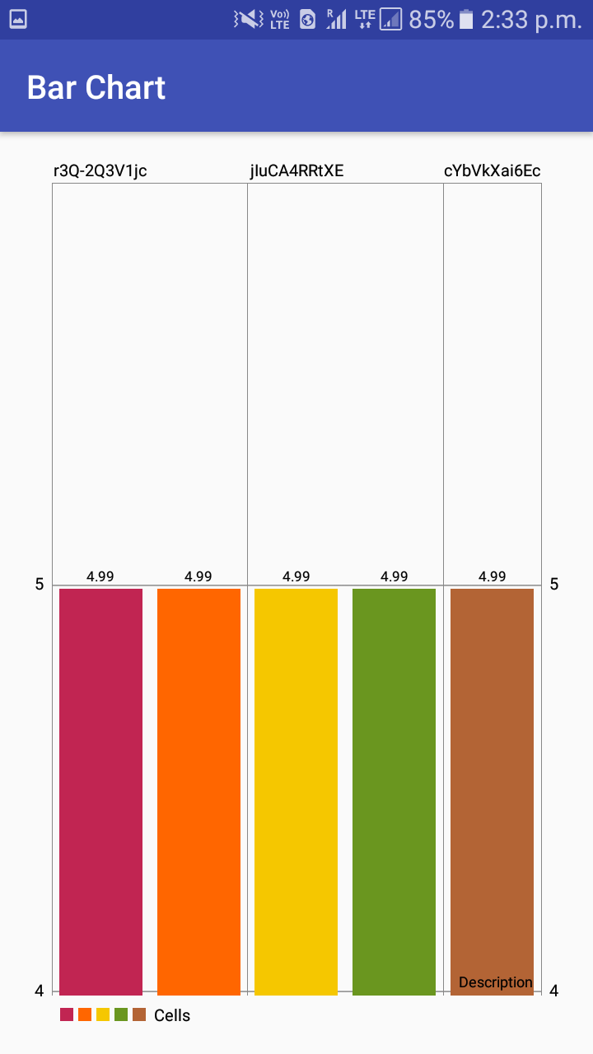

**APPLICATION**

From this project, we will be getting a bar chart or a list of all the top data set which will be helpful in identifying the top views, categories in YouTube.

**REFERENCES**

* https://en.wikipedia.org/wiki/Data_analysis
* https://www.tutorialspoint.com/hadoop/hadoop_mapreduce.htm
* https://hadoop.apache.org/docs/r1.2.1/mapred_tutorial.html